The City with a Vision

Kyiv – 75 km
Minsk - 589 km
Warsaw – 797 km
Bratislava - 1317 km
Budapest - 1108 km
Bucharest - 860 km
Chisinau – 429 km
Lviv – 510 km
Odessa 443 km
Kharkiv 548 km

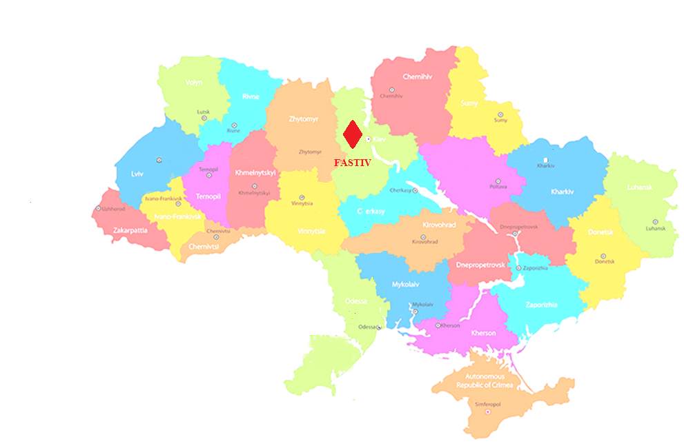

FASTIV

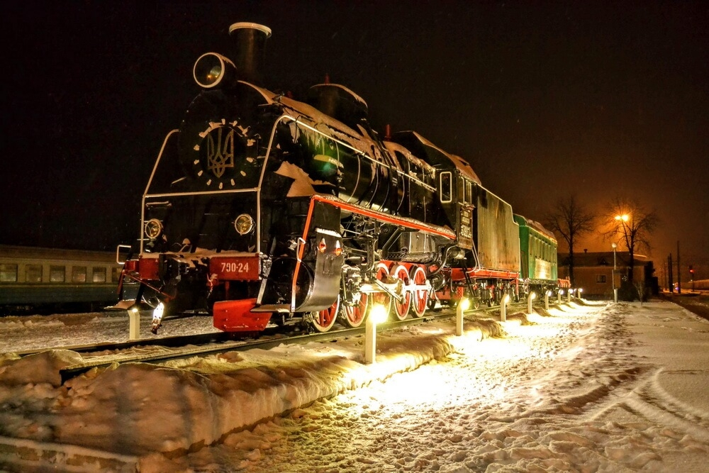
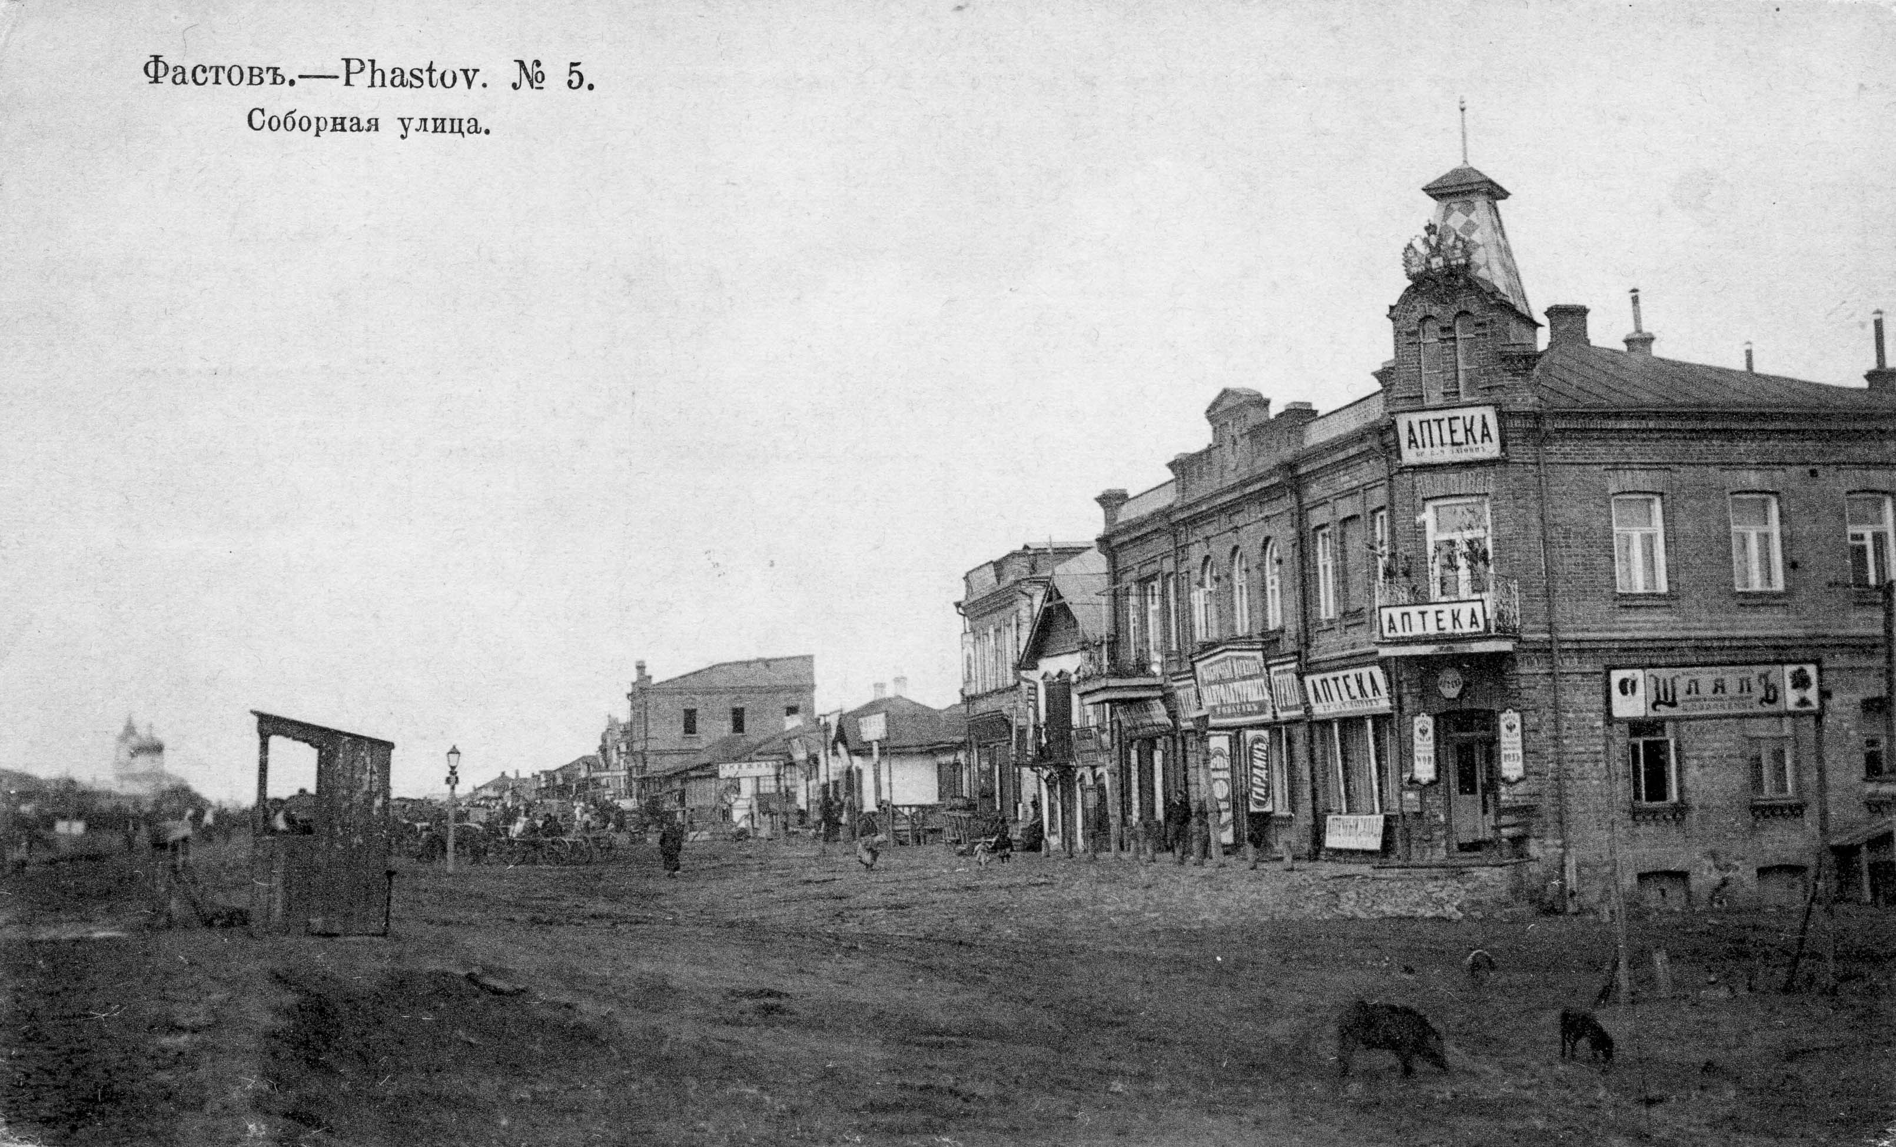
HISTORY

Year of foundation – 1390

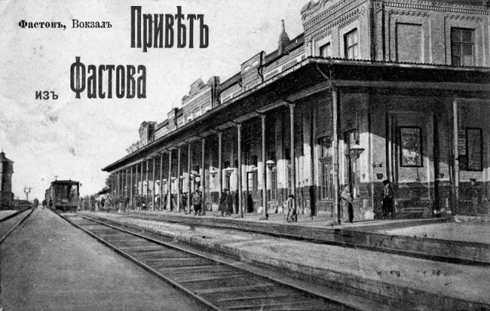

The development of Fastiv has accelerated since 1870, when the Kyiv-Odesa railway was laid through the City.
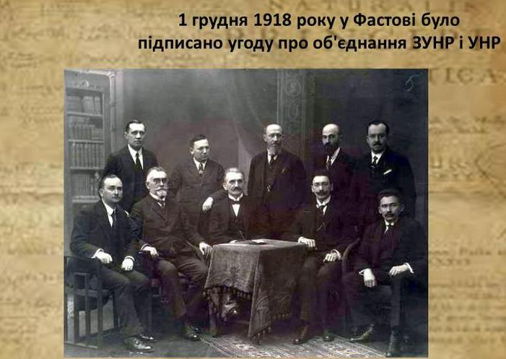

The Treaty of Ukraine Unity was signed in Fastiv City on December 1, 1918

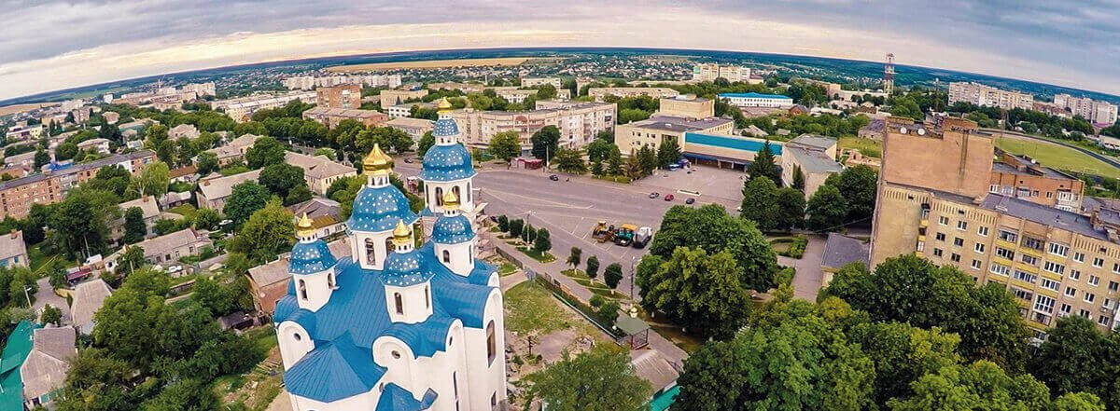
FASTIV CITY

Fastiv is a city of regional weight, a multi-sector industrial centre and an important railway junction.
The city is located in 75 km to the southwest of the Ukrainian Capital City, Kyiv, on the banks of the Unava River.
The total area of Fastiv is
– 4,563 hectares, which makes it one of the largest cities in the Kyiv Region.
Population:
50 thousand people
- 46% - men
- 54% - women
The advantageous transport and geographical location of Fastiv brings about an attractive investment climate for investors. The distance to Kyiv is 57 km by rail, 75 km by highway, and the distance to the nearest airport ("Kyiv Airport") is 75 km.
Strengths
- Diversified city economy
- Close location to the capital city of Ukraine
- Engineering and transport infrastructure is well-developed
- High culture of industrial production
- Significant volumes of agricultural products, wood and raw materials for production of construction materials
- High educational level of the population
- Favourable recreation conditions

Some of the major Ukrainian companies in the railway industry operate in the railway hub of the City.

- The Refrigerator Car Branch of UKRZALIZNYTSIA PJSC offers international freight forwarding services in delivery of cargoes, repair of railway cars, overhaul of cranes in rebuilding trains and rail carts.
- Fastiv-1 Motor Train Depot is engaged in capital and restoring repairs of electric trains.
- Fastiv-1 Railway Station is one of the most significant stations of the Southwest Railway. The Enterprise handles unloading, loading and despatching of railway cars.

HUMAN CAPITAL
PROFESSIONAL TRAINING
- Fastiv Road-Transport Vocational School (a higher educational institution of I-II accreditation levels).
- The Fastiv Vocational Training Centre.
The highly educated manpower potential is the City’s advantage. However, the unavailability of jobs makes about 10 thousand people go to work in Kyiv daily.

MANPOWER MARKET
In 2019, 7.5 thousand people (more than 16% of the City's population) worked in Fastiv.
Commerce is one of key sources of income for more than 34% of the working population. The transport sector is the second largest sector (6%). Industry and construction are also very significant sectors in Fastiv and account for 14% of the employees in the City.
The highly skilled manpower and relatively competitive labour cost are the City's strengths.

Fastiv Employment Structure
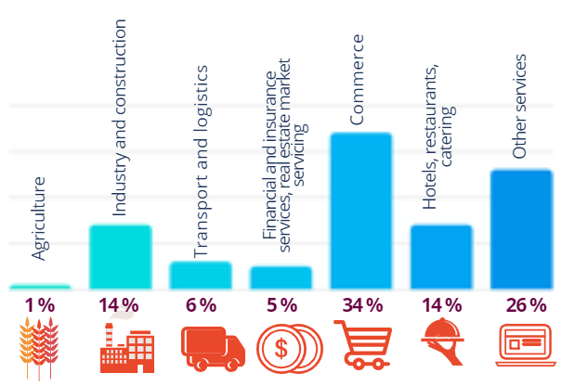
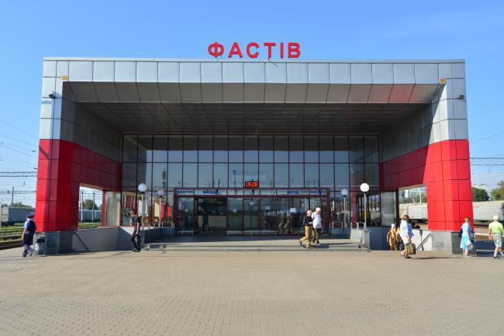
INFRASTRUCTURE and RAILWAY
TRANSPORT INFRASTRUCTURE
The City of Fastiv is located in the northern part of Ukraine in the Kyiv Region, and borders on the Zhytomyr Region in the west.
Its strategic location is due to proximity to Kyiv (the capital city of Ukraine) and transit routes.
HIGHWAY AND RAIL NETWORKS
The advantage of Fastiv is its proximity to transcontinental routes, namely, the location between 2 European highways:
Corridor No. 3 (E40) -
Belgium, Germany, Poland, Ukraine, Russia, Kazakhstan, Uzbekistan, Turkmenistan and Kyrgyzstan
Corridor No. 5
(East-West) Venice, Trieste/Koper, Ljubljana,Maribor, Budapest, Uzhhorod, Lviv, Kyiv
Corridor No. 9 (E95) -
Finland, Russia, Ukraine, Belarus, Moldova, Romania, Greece
Distances to certain Ukrainian cities:
- Kyiv - 75 km
- Kharkiv - 548 km
- Dnipro - 538 km
- Odesa - 443 km
The distance to the nearest airport ("Kyiv Airport") is 75 km
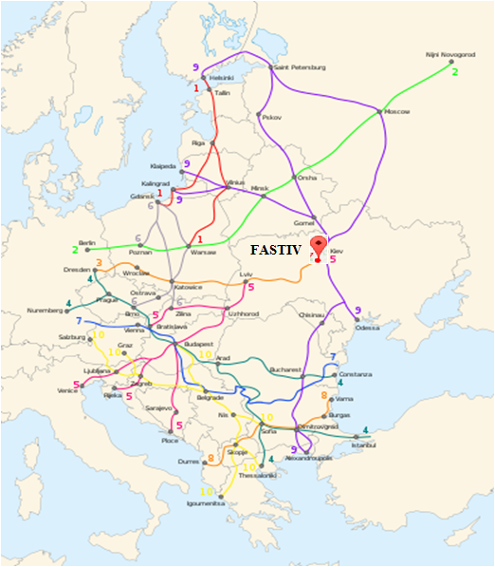
RAILWAY LINKS
Fastiv is a powerful railway junction having direct railroad links with many regions of the country, and the railroad trip to Kyiv takes about 1 hour.
The main electrified railway track passes through the City. Suburban, passenger and freight trains run in 4 directions from the City: to Kyiv, Koziatyn I, Myronivka and Zhytomyr.
The railway journey from Fastiv to Kyiv takes
1 hour and 12 minutes

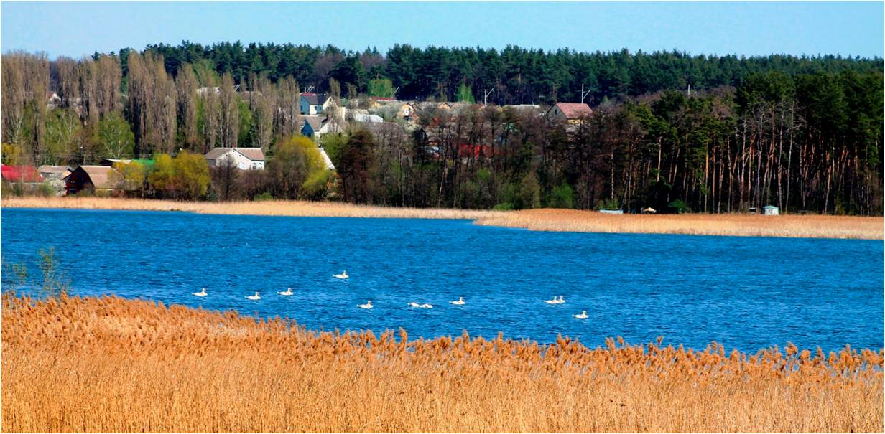
NATURAL RESOURCES
River - Unava
Within the city:
Length - 6.2 km
Volume - 6.5 million m³ of water
Surface area - 330 hectares

Natural zone: the merge of woodlands and forest areas

To the north and west: pine and oak forests
To the south and east: black soil fields

Minerals
- Construction and trim stones
- Limestone, gypsum and chalk
- Clay-slate
- Gravel and rubble
- Sand

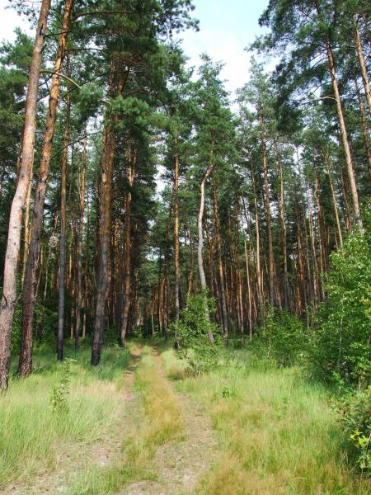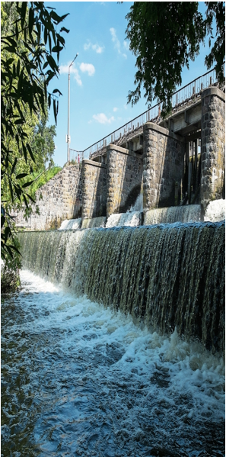

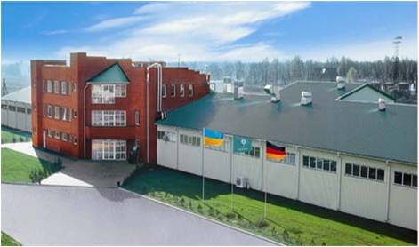
ECONOMIC POTENTIAL
The city's development is known for the intensification of economic activity, including, reorganization of industrial complex operation, intensifying construction, restoring of investments and the creation of new jobs.

The production potential of the City is ensured by 18 industrial enterprises operating in various industries.
MAJOR INDUSTRIES DEVELOPED IN THE CITY
- Engineering
- Printing
- Light (garment) industry
- Construction industry
- Chemical and petrochemical industry

FOREIGN CAPITAL

The key direction of the investment policy of
Fastiv is creation of favourable conditions for
business development, further improvement
of the investment climate, assistance in implementationof economically significant investment projects with theinvolvement of all sources of finance.

The foreign incorporators of enterprises
operating in Fastiv include companies from
China, Germany, Norway and Cyprus.

The City’s companies are engaged in foreign trade operations with partners from all over the world,
including Austria, Azerbaijan, Belarus, Bulgaria,
the British Virgin Islands, Vietnam, Georgia,
Estonia, Israel, Kazakhstan, China, Latvia,
Lithuania, Luxembourg, Moldova, Germany,
New Zealand, Poland, Russia, Singapore, the USA,
Turkmenistan, Hungary, Switzerland, Sweden.
Major enterprises:
Refrigerator Railway Car Subsidiary Company
Ukrainian Railways JSC
Univest Marketing Company LLC
Elopak-Fastiv PJSC
Zibert Brewery LLC
EKO-VTOR LLC
Fakel PJSC
FASTIVSKE KHPP LLC
Kyivkhlib LLC
PolyGreen Company LLC (Fastiv Branch of KPD LLC).
Kreisel Construction Materials LLC
FLK-INVEST LLC

Electric Heater SALC
Fastiv Forestry State Run Company

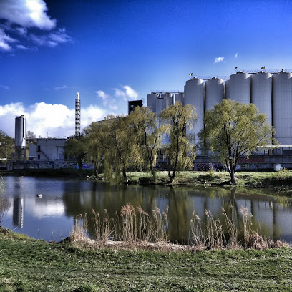

Fastiv’s Strategic Initiative | The Fastiv Local Economic Development Plan for 2019-2020 was developed and agreed in Fastiv City, which includes, in particular, creation of the FastIV Industrial and Logistics Cluster.  On April 18, 2019, the constituent assembly was formed and held. Representatives of 21 enterprises subscribed to the FastIV Industrial and Logistics Cluster.  The FastIV Industrial and Logistics Cluster is organic neighbouring of 4 important components: industry, logistics, innovative educational space and business development centre:
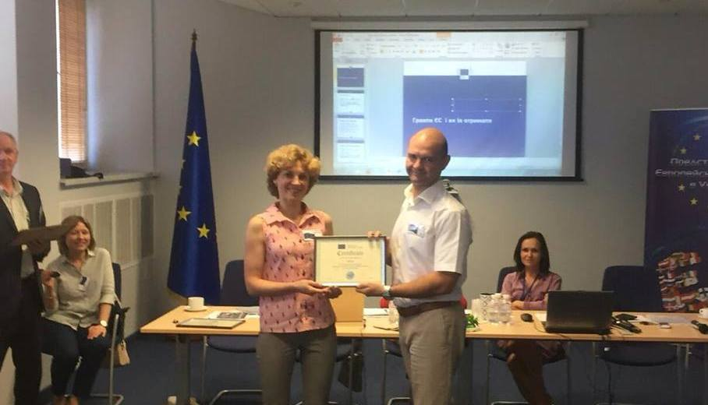  2017 Fastiv joined the European Initiative  Mayors for Economic Growth  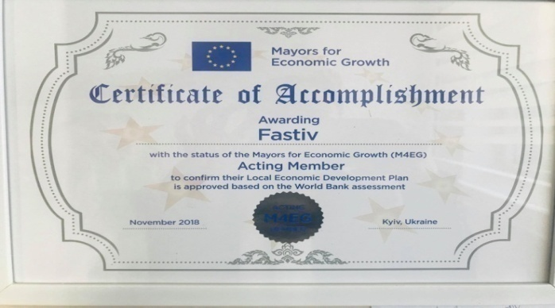 | «FastIndustry» Industrial Park:  The equipped area (15 hectares) for new facilities in the field of industrial production,logistics, and related services.  «FastLogistic» Logistics Hub:  Klaipeda-Fastiv-Odesa railroad and sea freight line extending to the ports of Asia and Africa. Transportation is expected to include mainly containers shipments (universal and refrigerator containers).  «FastDevelopment»  Local Development Centre:  The centre to be formed in order to encourage development of entrepreneurship in the City, providing of services aimed at business improvement and ensuring of better access to finance.  «FastKnowledge»  Innovation Educational Environment:  The education environment expected to contribute to better opportunities of students,entrepreneurs and individuals in prompt of the modern knowledge required for the development of the City`s entrepreneurship and economy.
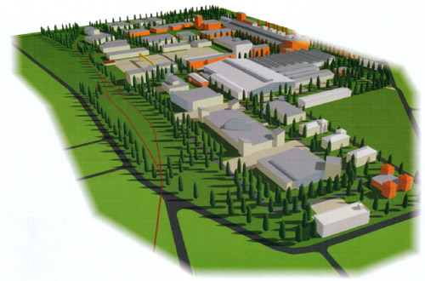
«FastIndustry»Industrial Park

Date of inclusion in the Register: 13.01.2017
Creator Initiator: Fastiv City Council
Managing Company: Start-Industry LLC
Location: city Fastiv of Kyiv region
Land plot area: 15 hectares
Form of ownership of a land plot: communal

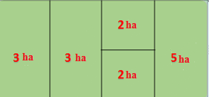

Location: The land plot is divided into 2-3 ha
to accommodate the production facilities
of 5 enterprises.
Design capacity for electricity is 10 MW

Infrastructure:
- Distance to the route Kiev-Odessa E95 - 25 km;
- distance to Kiev-Zhitomir E40 - 52 km
- distance to the railway station of the Fastiv II station - 700 m;
- Distance to the Kyiv-based airport - 75 km;

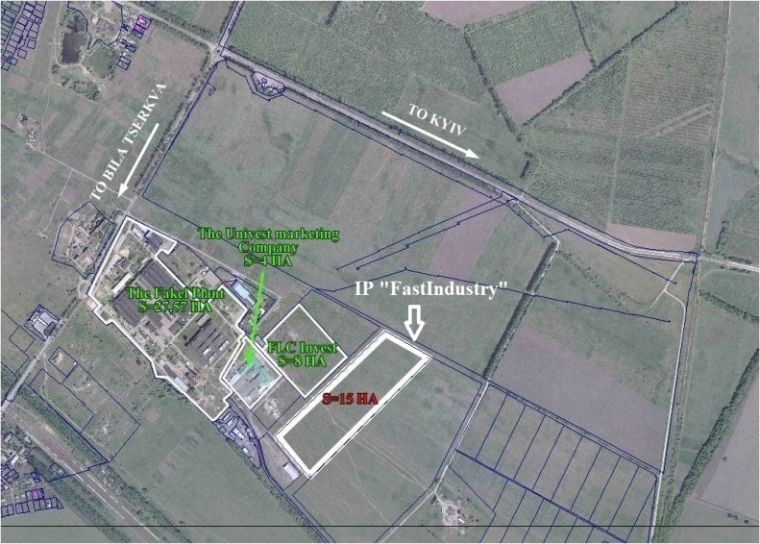

Benefits:
- 0 % duty rate for imported equipment;
- 0% share participation in IP infrastructure development;
- 25% governmental support of IP development (connection to utilities and transport infrastructure);

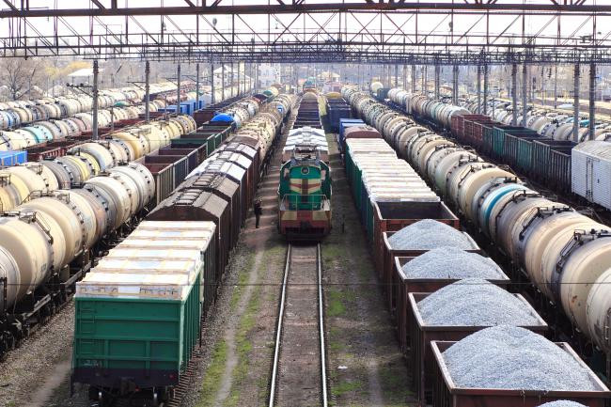
«FastLogistic» Logistics Hub
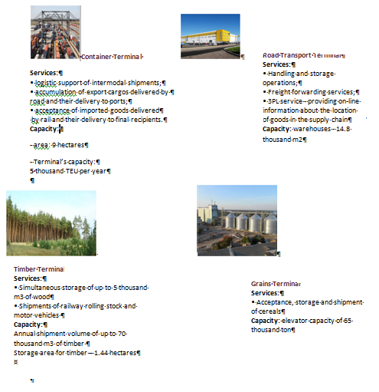

«FastDevelopment» Local Development Centre
FD Local Development Centre is a driver of economic development of the city and the coordinator of public bodies’ efforts aimed at stimulating of entrepreneurship and improvement of business conditions

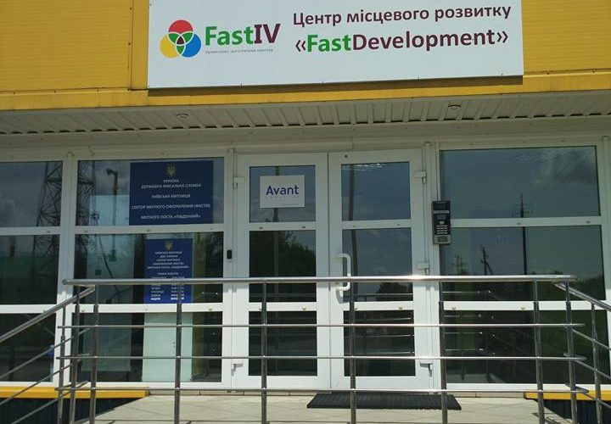
Services:
- searching for, follow-up and support of investors;
- related and administrative services (customs, certification, phyto-sanitation, etc.);
- organising of consultations and trainings on regulatory aspects of business conducting;
- marketing support;
- office and conference premises rental services;
- better access to finance

NATURAL RESOURCES
River - Unava
Within the city:
Length - 6.2 km
Volume - 6.5 million m³ of water
Surface area - 330 hectares

Natural zone: the merge of woodlands and forest areas

To the north and west: pine and oak forests
To the south and east: black soil fields

Minerals
- Construction and trim stones
- Limestone, gypsum and chalk
- Clay-slate
- Gravel and rubble
- Sand

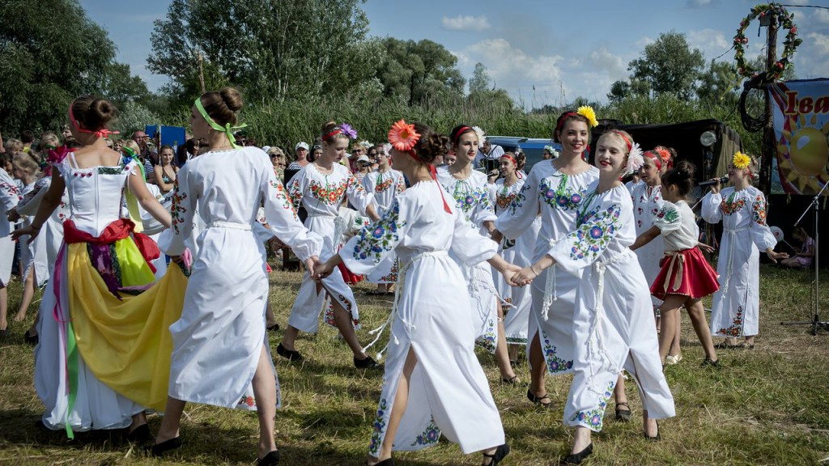
CULTURE and LEISURE
The network of cultural institutions of the City includes:

- Fastiv State Museum of Natural History
- Fastiv Music School for Children
- Fastiv City Palace of Culture
- Fastiv City Library
- Fastiv City Youth Centre
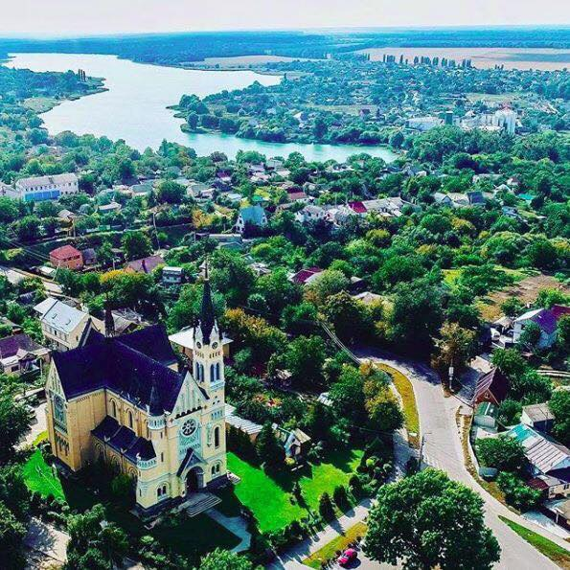
There are 32 clubs operating on the basis of the City Palace of Culture, including:
- 22 clubs for children
- 6 National Clubs
- 4 Recognised Clubs.
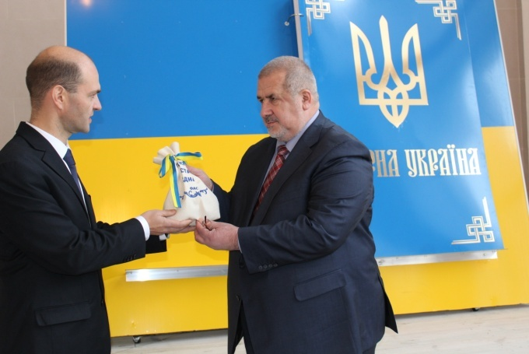
MEMORIALS AND MUSEUMS
- Virgin Intercession Orthodox Church (ХVI century)
- Holy Cross Elevation Roman Catholic Cathedral (early ХХ century)
- Museum on Wheels – the museum was established to commemorate signing of the Treaty of Unity between the Ukrainian People's Republic and the Western Ukrainian People's Republic at the Fastiv Railway Station on December 01, 1918.
- Fastiv State Museum of Natural History

The City’s downtown features:
- the city park, and
- MOLODIZHNY Garden Art Monument Park (14,7792 hectares).

Festivals and Cultural Events
- Festival of European Nations’ Cuisines
- Street Food Festival
- Europe Day
- City Day
- Dorohynska Sich Festival
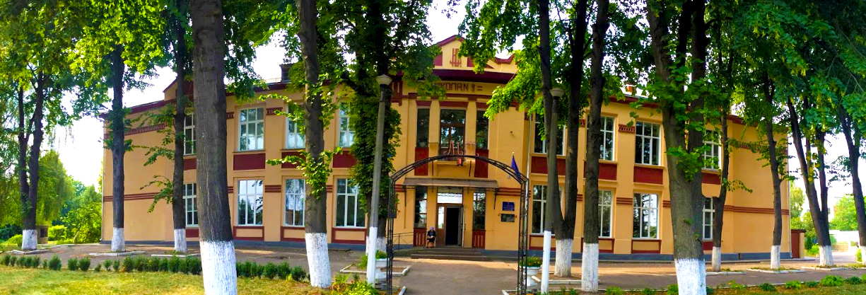
EDUCATION, SPORTS and MEDICINE

The City has
- 1 Road-Transport Vocational School;
- 1 Vocational Training Centre;
- Fastiv School of Arts and Crafts
- 2 lyceums:
- Lyceum of Information Technologies, School No. 9,
- Lyceum of Natural Sciences and Mathematics, School No. 2";
- 1 specialised school:
- Secondary School No. 4 with Advance Learning of Foreign Languages;
- 5 educational and training complex facilities, including:
- School No. 7, GART Centre of Military and Patriotic Education;
- 1 upper secondary school;
- 2 secondary schools;
- 1 evening school.
Since 2016, the City has a training and rehabilitation centre for children with special needs
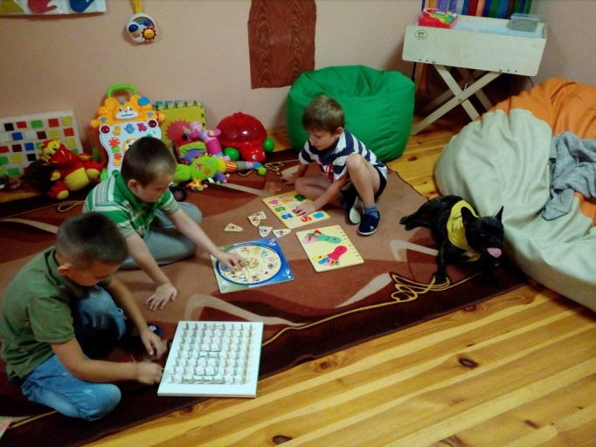

Sports Sections:
Basketball, Boxing, Canoe Rowing,Volleyball, Judo, Grappling, Wing Chun (Chinese School), Kyokushinkai Karate, Jiu-Jitsu, Sportive and rhythmic gymnastics, Shooting, Football, Pankration, Tennis, Badminton, Athletics.
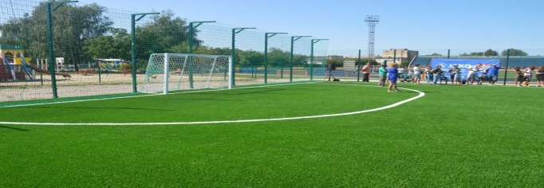

Fastiv has medical facilities providing medical care:
- Fastiv Municipal Centre of General Medical Services, a Communal Non-Commercial Company of the Fastiv Municipal Council;
- Fastiv Municipal Centre of General Medical Services, a Communal Non-Commercial Company of the Fastiv District Council;
- Fastiv Central District Hospital, a Communal Non-Commercial Company of the Fastiv District Council;
- Emergency Medical Services: Fastiv Branch of Kyiv Region Centre of Emergency and Disaster Medicine, a Communal Institution of the Kyiv Region Council.
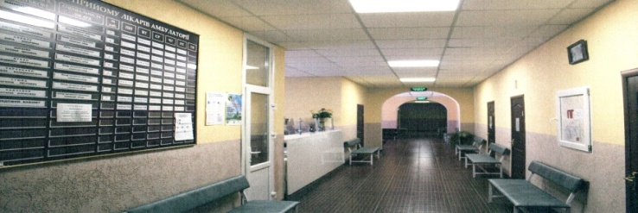

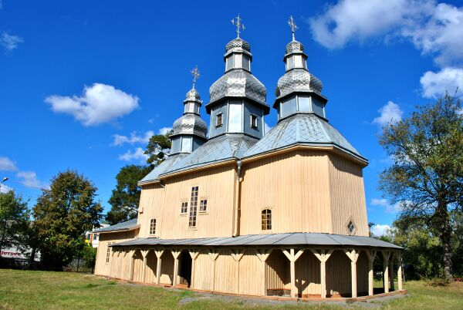
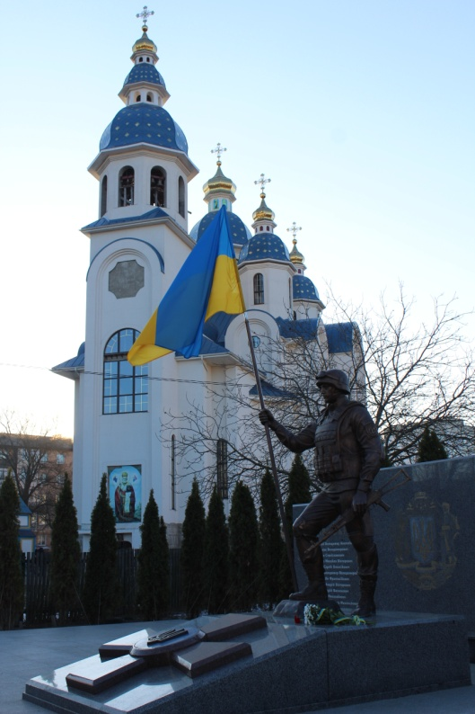
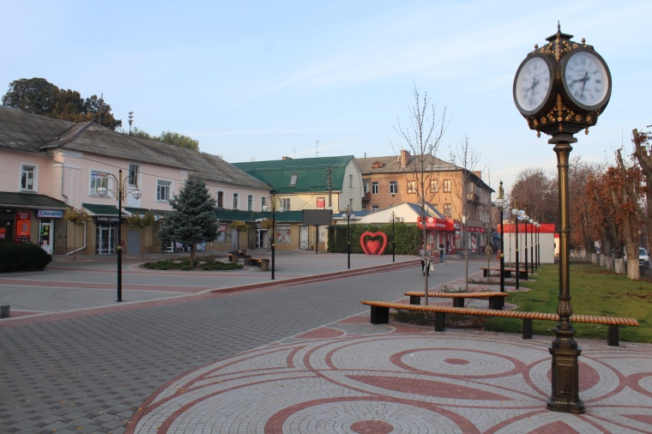

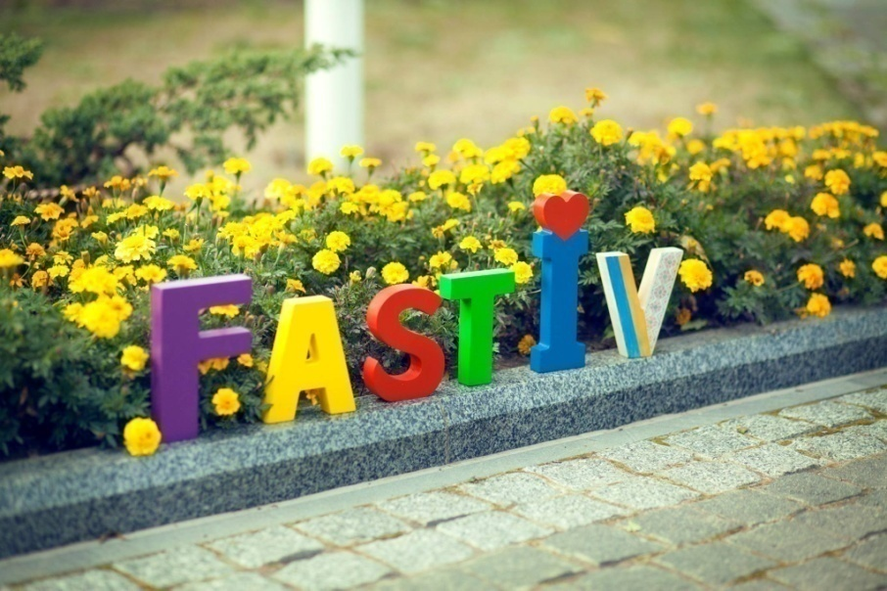

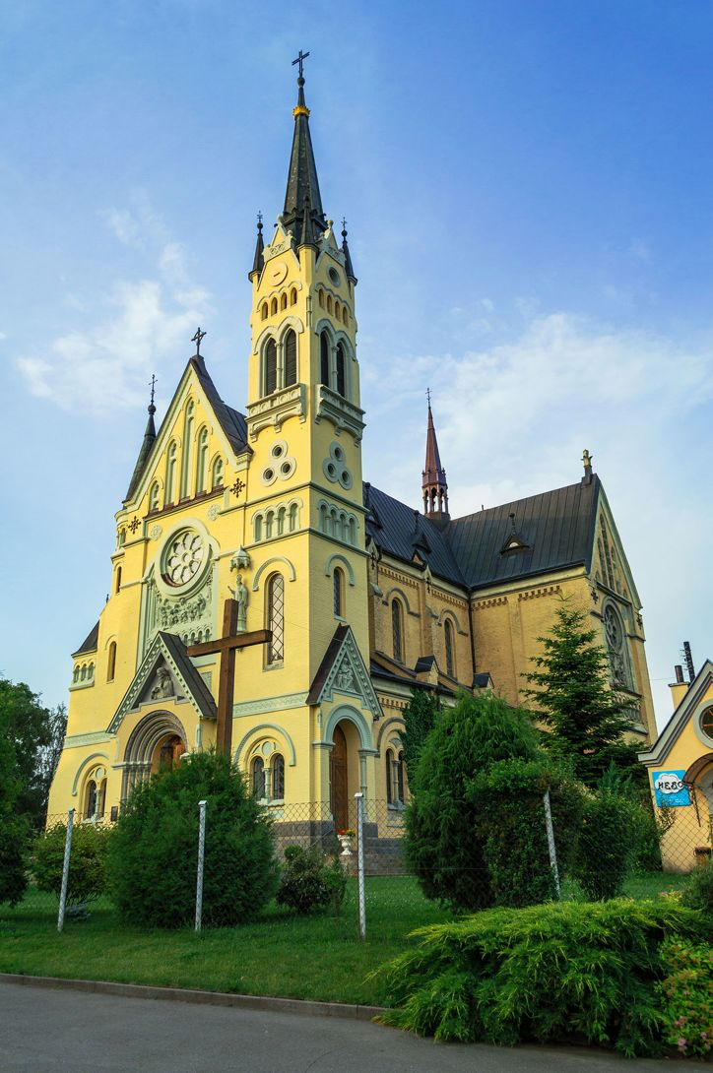

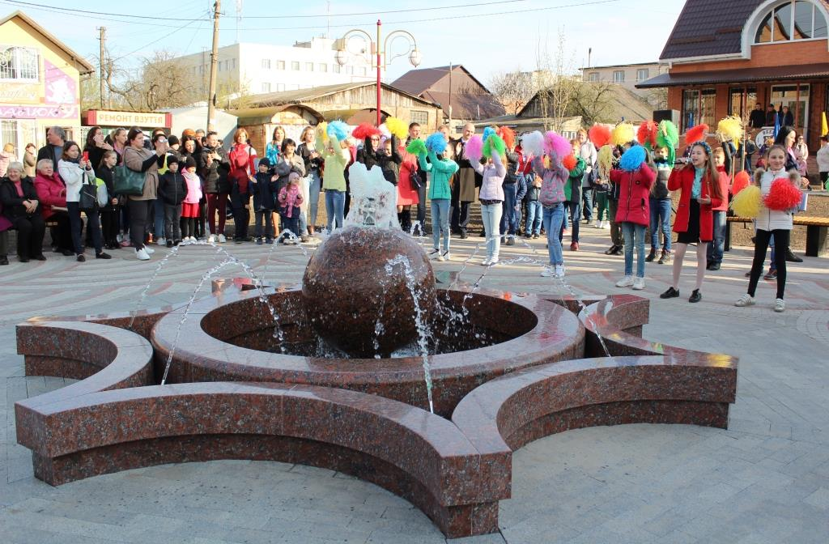

FASTIV CITY COUNCIL
EXECUTIVE COMMITTEE
1, Soborna Sq, Fastiv
Kyiv region, Ukraine, 08500
Tel.: +38-04565-6-02-16
Fax.: +38-04565-6-31-00
E – mail: info_fastiv-rada@ukr.net
www.fastiv-rada.gov.ua
www.facebook.com/radafastiv

